Robot codes

Name - Ranjit singh

Student Id - 202112053

1). Simple Hut Design code

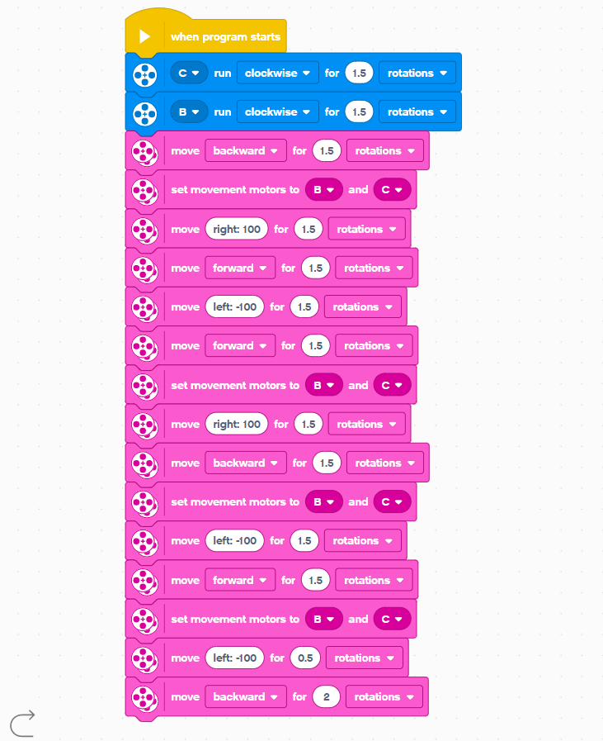

2. Design a Square

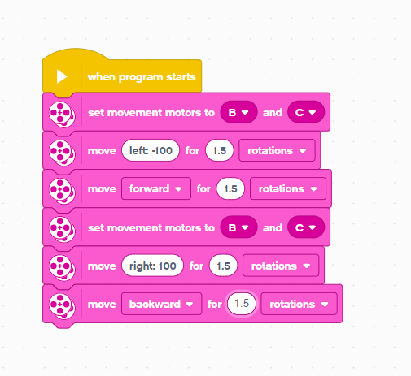

3). Two Triangles with lines code

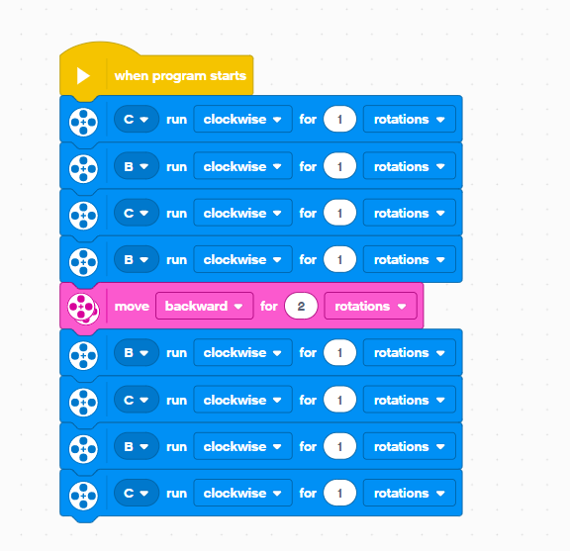

4). Cube with Triangles code 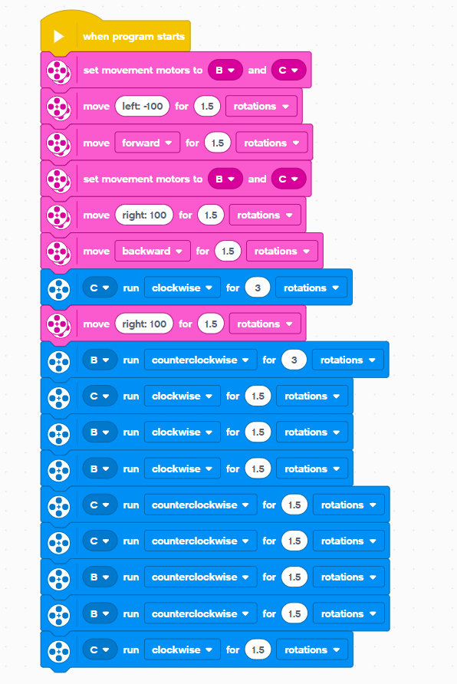

5). Diamond design code

